Intermediate report

Self learning software to identify illegally traded orchid material

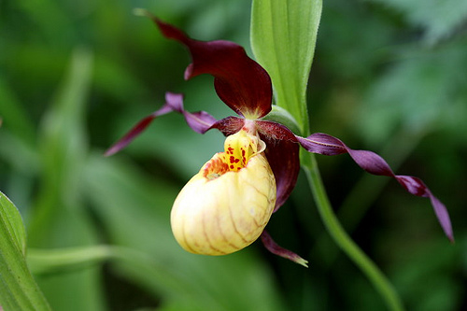

Figure 1 *Cypripedium calceolus* [1]

Patrick Wijntjes, s1057924

University of Applied Sciences Leiden, Bio-informatics, Technology cluster  
Zernikedreef 11  
2333 CK Leiden

Period 02-09-2013 till 27-06-2014

Naturalis Biodiversity Center   
Sylviusweg 72  
2333 BE Leiden

Supervisors:  
Dr. Barbara Gravendeel and  
Dr. Rutger Vos

Lecturer from school:  
Drs. Jan Oliehoek

Table of Contents

Introduction 3

CITES 3

Study group 3

How a web application can improve control in illegal orchid trade 4

Comparable software 4

Materials and Methods 5

Website 5

Training 5

References 6

Appendix 1 8

# Introduction

## CITES

There are thousands of different orchid species known all over the world [2]. None of these are allowed to be imported into the Netherlands without CITES permits.

Since 1973 orchids are primarily protected by the Convention on International Trade in Endangered Species of Wild Flora and Fauna (CITES), which is signed by over 120 nations [3]. Despite this convention many orchids are illegally traded. To trade species that are protected by CITES, a licence or certificate is required. Each nation who signed the Convention must designate one or more Management Authorities. They are in charge of administrating that licensing system. All the nations have also to designate one or more Scientific Authorities. They advise the Management Authorities about the effects of trade on the status of the species.

It is difficult to monitor the illegal trade of orchids because some orchids look very similar to non-protected plants. So sometimes it is difficult to tell if the imported species is an orchid or not. To improve identification, software that can identify orchids from pictures of tubers, leaves or flowers can be useful.

## Study group

During this project the focus is on slipper orchids and orchids from which *salep* is produced.

In Europe and Asia the slipper orchids (*Cypripedioideae*) are widely distributed between sea level up to 2000 m altitude. Species prefer to live in calcareous environments and are found in deciduous or mixed deciduous and coniferous woods. They grow best in light to deep shade. The slipper orchid is an herbaceous perennial plant species that can live very long. It can grow up to 60 cm and each season the slipper orchid will produce new growths. Each stem of the orchid can contain 3 to 4 leaves that often have upcurved sides. The flower stalk can be one-flowered or two-flowered with leaf-like bracts. The sepals and petals are rarely green but commonly brightly coloured. They are also often twisted [4]. Slipper orchids are highly desired ornamentals.

Ground orchid bulbs of the *Orchidoideae*, also known as *salep,* are very popular in Turkey. They are used to produce ice creams in summer and drinks during winter. *Salep* is also used as medicine. In the early 1990s the trade of *salep* increased strongly. The official statistics from the Turkish State Institute of Statistics show that the export between 1995 and 1999 was 282.000 kg annually. It is unknown if this information is related to pure *salep*, substitutes or mixtures. To achieve this amount of *salep* 9.825.000 – 19.650.000 bulbs are required. This is far too much so there are some laws established to protect these orchids. In Turkey there are three laws that would protect them. The first law is the Turkish Forest Law. This law regulates the use of non-wood forest products. In short this law states that it is forbidden to collect and remove any form of forest vegetation. The second law, the Turkish Law of Natural Parks states that “The production of forest products, hunting and disturbing the natural balance is prohibited.” Since collecting *salep* is classified as production of forest products, it is prohibited in all protected areas. The last law in Turkey is The Regulation on Collection, Production and Export of Bulbs of Wildflowers. As the title of this law reveals, this law regulates the production and the export of bulbs, roots and tubers of flowers. It also holds a list with species that may not be taken away from the wild for export [5].

## How a web application can improve control in illegal orchid trade

To make it easier to follow the trade routes of orchid smuggling, a web application that can identify different orchid species would be handy. This application can be used on laptops/desktops and smartphones/tablets by taking pictures of flowers, leaves and underground tubers and upload the pictures to the website. A simple workflow of the application can be found in figure 2. In this project the focus is on creating the website and integrate the identification application. This application is already available at Naturalis, and is not developed during this internship.

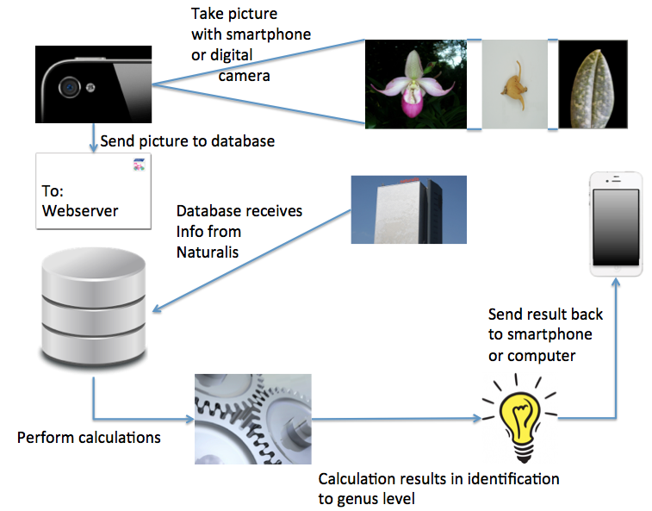

Figure 2 A simple workflow of the application made during this project. Resources of the pictures: [7-16]

## Comparable software

There is software available that can identify a person using face recognition. One example of software like this is KeyLemon [20]. This software could be used to unlock a computer.

The overall operation of software like this is to take a picture or series of pictures of your face. When it takes a series of pictures it is almost always required to move your head up and down and / or left and right. The software saves this picture / these pictures. When you use the software to unlock your computer the software takes a picture / a series of pictures of your face and compares this picture / these pictures with the saved picture(s). When it finds a match you will be logged-in to your own account.

# Materials and Methods

## Website

During this internship a website is developed. The processes behind this website are written in Python2.7 using the Django package. The layouts of the webpages are written in html, using css style sheets. There are two versions of every html file, one for computers and one for mobile devices. The different python scripts, html files and css style sheets can be found in appendices x-y. Because there is little difference between the computer htmls and the mobile htmls only one mobile html can be found in these appendices.

## Training

During this internship the software is trained to see the differences between orchid tubers and tuber of orchid look-a-likes. The look-a-likes that are used are *Arum maculatum*, *Asparagus officinalis, Polygonatum verticillatum, Tulipa greigii,* and *Tulipa sp.* [18]. Appendix x contains pictures of these tubers.

Before training of the software is possible there are many steps to prepare the training.

First of all pictures of the orchid tubers and the tubers of the look-a-likes are required. So in the first few weeks of this internship pictures are taken at the Sylvius lab.

Although the orientation of these tubers is unregulated, it is required that it is the same for all pictures. For instance, if the first picture of a tuber with spurs has the spurs on the right, all other tubers with spurs must have the spurs on the right. The user has to use the same orientation as the trainer, so this can be found in the user guide. The background has to be one colour, like white or black, and this colour must be the same for every picture. The last requirement is that there is only one tuber on the picture.

The pictures are uploaded to a shared Flickr account. On Flickr it is possible to add tags to the pictures. These tags are used later in the preparation process to save the pictures in the correct directory. To download the pictures and the meta data via the command line, a python script written by Hugo Haas, Offlickr, is modified and used (see appendix x) [*].

During this internship a Python script is developed to automate the steps of the preparation process (see appendix x). The first step in this process is to download de pictures and meta data and search for the tags in the meta data. The next step is to convert the pictures from jpg- to png-format and place the picture to the correct directory (Round, Spur and Oblong for the different orchid tubers and LRound, LSpur and LOblong for the different look-a-like tubers) using the tags. The last step is to create the trainings data. This is a tab separated value file for every directory.

The Python script developed during this internship runs some Perl scripts developed by Rutger Vos (see appendix x-y).

# References

[1] Royal Treatment for the Lady’s slipper, 2013, <http://www.empowernetwork.com/justiniskandar/blog/royal-treatment-for-the-ladys-slipper/>

[2] The Plant List, 2010, <http://www.theplantlist.org/browse/A/Orchidaceae/>

[3] Orchid Smuggling and Conservation (ORCHID), <http://www1.american.edu/ted/orchid.htm>

[4] Royal Botanic Gardens Kew, 2001, <http://www.kew.org/plants-fungi/Cypripedium-calceolus.htm>

[5] Kasparek M and Grimm U, 1999, European trade in Turkish Salep with Special Reference to Germany. Economic Botany 53(4): 396-406

[6] Stergiou C and Siganos D, Neural Networks, [http://www.doc.ic.ac.uk/~nd/surprise_96/journal/vol4/cs11/report.html - Introduction to neural networks](http://www.doc.ic.ac.uk/~nd/surprise_96/journal/vol4/cs11/report.html#Introduction%20to%20neural%20networks)

[7] Camera: gsmnationblog, 2013, <http://www.gsmnation.com/blog/2013/02/19/snap-away-5-best-smartphone-cameras-available/>

[8] Envelop: Tuxx, 2004 - 2013, <http://www.tuxx.nl/post/adressering/>

[9] Naturalis tower: unityfm, 2013, <http://www.unityfm.nl/nieuws.php?id=26906>

[10] Database: introduction to query optimizer, 2013, <http://prabathsql.blogspot.nl/2013/01/introdiuction-to-query-optimizer.html>

[11] Wheelwork: op eigen kracht praktijk voor ergotherapie, 2013, <http://www.ergotherapieopeigenkracht.nl/vergoeding-ergotherapie/>

[12] Lamp: ledweeklampen, [http://www.ledkweeklampen.nl](http://www.ledkweeklampen.nl/)

[13] iPhone: T-Mobile, <http://shop.t-mobile.nl/eca/RAPRD/Apple-iPhone-4-8GB-wit/map48gbpwi.html?ab_agid=1021>

[14] Slipper orchid: Wikimedia commons, 2009, <http://commons.wikimedia.org/wiki/File:Slipper_orchid_wyn1.jpg>

[15] Orchid leaf: A Close-up View of a Lady's Slipper Orchid, Brian Johnston, 2012, <http://www.microscopy-uk.org.uk/mag/artjan12/bj-slipper3.html>

[16] Photographs by Patrick Wijntjes

[17] Sanz E, von Cramon-Taubadel, N and Roberts, DL. 2012. Species differentiation of Slipper Orchids using Color Image Analysis. Lankesteriana 12(3): 165-173

[18] Lawler LJ, 1984, Ethnobotany of the Orchidaceae, In: Arditti J (ed.), Orchid biology: reviews and perspectives: 27-149. Cornell University Press, Ithaca, New York, USA

[19] Leafsnap, 2011, <http://leafsnap.com/>

[20] KeyLemon, 2013, <https://www.keylemon.com/product/>

[21] Pridgeon AM, Cribb PJ, Chase MW and Rasmussen FN, 1999, Genera Orchidacearum Volume 1

[22] Pridgeon AM, Cribb PJ, Chase MW and Rsamussen FN, 2001, Genera Orchidacearum Volume2 Orchidoideae (Part one)

[23] Rogier van Vugt, Naturalis Biodiversity Center

[24] Horticultural Supplies for Exotic Plants Orchids, Bonsai, African Violets & Tropicals, 2005-2013, <http://www.repotme.com/orchid-care/Orchid-Identification.html>

[25] GitHub, 2013, <https://github.com>

[26] Python, 1990-2013, [http://www.Python.org/about/](http://www.python.org/about/)

[*] Offlickr, Hugo Haas, <http://code.google.com/p/offlickr>

# Appendix 1



Figure 3 *Arum maculatum* [16]



Figure 4 *Asparagus officinalis* [16]



Figure 5 *Polygonatum verticillatum* [16]



Figure 6 *Tulipa greigii* [16]



Figure 7 *Tulipa sp.* [16]